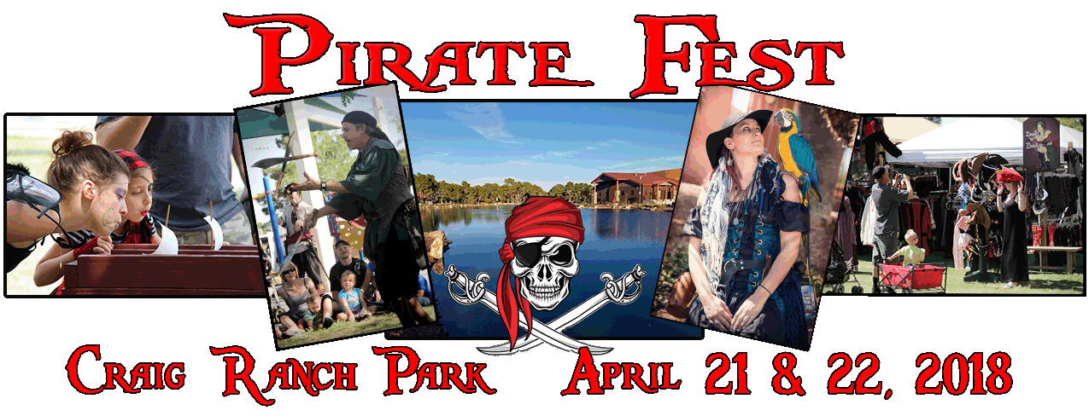
FOR IMMEDIATE RELEASE
The Pirates Drop Anchor at Craig Ranch Park!
The 6th Annual Pirate Fest is at Craig Ranch Regional Park, April 21 & 22. Produced by R & J Production the creators of the Halloween event at the Meadows Mall. Pirate Fest is a fun family festival including Pirate, Steampunk, Renaissance and Faerie characters. There will be live entertainment, music, food, vendors, strolling characters, mermaids, games, activities and a beer garden.
Kids follow a Treasure Map to complete tasks. Activities include making a rope; walk the plank, swab the deck, hoist the sails, get a pirate name, even make an eye patch or a fairy wand! Complete the map, receive a Letter of Marque and become an “Official Pirate”. We also have Pirate skill games for kids and adults that were originally designed for Pirate Fest.
New this year is the Pirate Puppet Show presented by Las Vegas Family Puppet Theater Co. Watch the puppets as they present the “Legend of the Pirates” to find out how the Pirates ended up here in the desert!
Although a family friendly event, Pirate Fest also caters to adults (that are just kids inside!) There is beer and of course RUM at the festival. New this year is a Whiskey/Rum Tasting presented by Master Mixologist Bobby Gleason of Beam Suntory. All proceeds from the tasting benefit Paradise Ranch Foundation, a local charity dealing with mental health though HAT (Horse Assisted Therapy) http://www.paradiseranchlv.com .
Do you want to be a real pirate? TWO lucky people will win a cruise aboard a REAL Tall Ship! You can register to win a TRIP for TWO aboard the historic tall ship S/V Mandalay from the Sail Windjammer Cruises. Hoist a sail, steer the ship, or just sit back and sip a margarita…err…RUM! Do as little or as much as you want!
You can qualify through our sponsors or at Pirate Fest. Qualifiers must be present to win!! Sail Windjammer of Las Vegas is providing this fantastic Caribbean cruise for TWO!!
Pirate Fest- Where you don’t just watch the pirates…you ARRR the Pirate!
For cruise info on the Tall Ship Mandalay go to: www.SailWindjammer.com
To register for the cruise or for more info log onto www.PirateFestLV.com
email: info@PirateFestLV.com
###
Jennifer Bradley 702-234-9385 jenniferbradley@cox.net

